Von Caemmerer (2000)















**Note: From above equation, 4.11 We can estimate Cs, as we have measurements for Amax ==Ac and Rubisco activity===Vcmax**





g0 = bundle sheath O­2 conductance

gs = bundle sheath CO2 conductance (Will use g­bs in future)







**Note: Equation 4.19 must be fitted for PEPC activity , with that Vp i.e rate of carboxylation by PEPC, must be equal to Vpr =80 at high CO2**





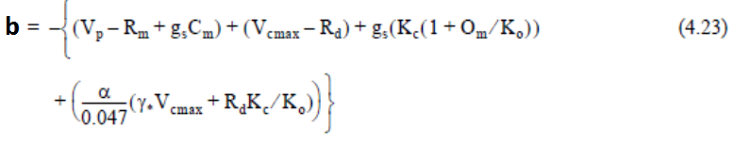





**Note: With this equation our model line should predict Aci response curve, with provided values of Vpmax, and Vcmax.**





**Rate of ATP and NADH consumption**





**Note: At high Ci we can ignore 4γOs /Cs as Cs is larger in eq 4.28**



**Note: Read Peisker 1988 to model Jt at low light**